4.01 Binary to Decimal Conversion

A simple procedure to convert binary numbers to decimals is illustrated in the following activity, for which you will need 16 index cards and a calculator (or pencil and paper). Write the successive powers of 2 on eight of the index cards (i.e., 1, 2, 4, 8, 16, 32, 64, and 128), one number per card. On the remaining eight index cards, write 0 on one side, and 1 on the other side. Numbers on each set of cards should be written in different colors and in a different orientation (see example below).

Converting binary numbers to decimal numbers is so simple you can teach almost anyone to do it. This is one of those activities that you can share at the dinner table, to the delight of young and old! Think of it as a computer science bonding activity. Younger brothers and sisters are usually eager volunteers, but don’t hesitate to involve older family members, too.

Warm up your audience with a few refresher questions.

Q: What number system do we use to do math?
A: The decimal number system. (Bonus points if they know it is base 10.)

Q: How many digits are there in the decimal number system?
A: 10 – 0, 1, 2, 3, 4, 5, 6, 7, 8, and 9

Q: What is the “place” value of each digit in the number 542?
A: The 5 is hundreds, the 4 is tens, and the 2 is onesies.

Q: Is 542 the same as 5 x 100 + 4 x 10 + 2 x 1?
A: Yes!

Now you have them where you want them, so ask if anyone has ever heard of the binary number system. Explain that “bi” means two (as in two wheels on a bicycle) and that a binary number can only contain 0s and 1s, which are called bits (for binary digits).

Ask for a volunteer from your captive audience and place the cards representing the powers of 2 on a table in front of you in decreasing order from left to right, then lay cards with binary digits beneath them. The pattern shown below is an example to get you started.

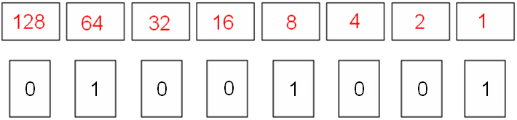

Ask the volunteer what pattern they see in the top row as the numbers increase in value from right to left. (You may want to point out that the place value of decimal numbers increase by a factor of 10 from right to left as well.)

Explain that the cards on the bottom row represent a binary number, and that the only numbers possible are 0 and 1. Tell your student to multiply each binary digit (in the bottom row) by its place value in the top row and find the total of the numbers with the calculator. For example,

Answer = 0 * 128 + 1 * 64 + 0 * 32 + 0 * 16 + 1 * 8 + 0 * 4 + 0 * 2 + 1 * 1
= 0 + 64 + 0 + 0 + 8 + 0 + 0 + 1
= 73

So, the binary number 01001001₂ = 73

Note: If your brother or sister is too young to understand this concept, you can switch it to an explanation of place value in decimal numbers.

